Methodology Document

* **Exploratory Data Analysis:**
  1. Data Inspection and cleaning: Checked the data for null values

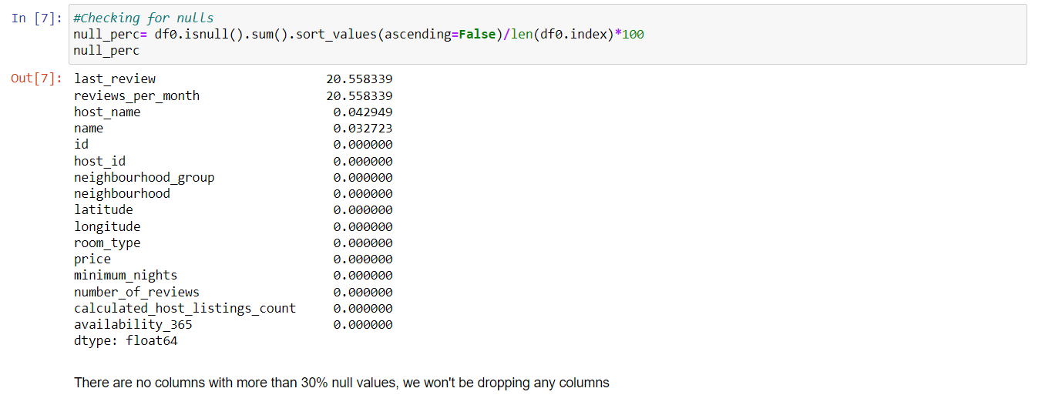

* 1. Dropped columns which are not relevant for analysis

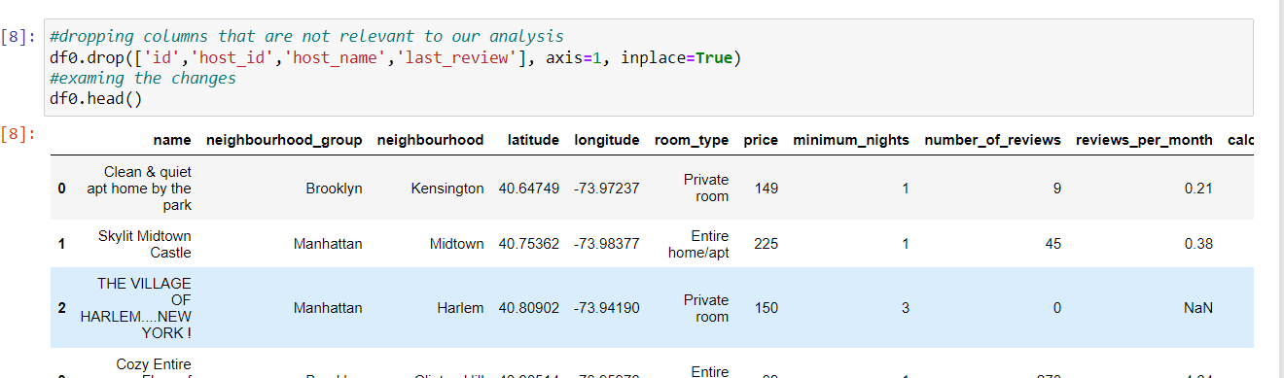

* 1. Replacing nulls with appropriate values

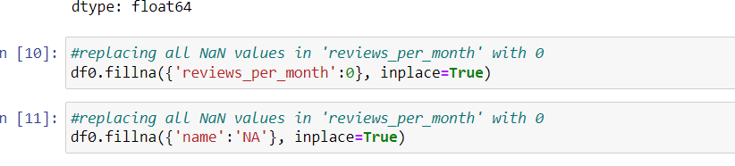

* **Univariate Analysis**
  1. Performed Analysis on categorical variables like **Top Properties, Neighbourhood, Room types**

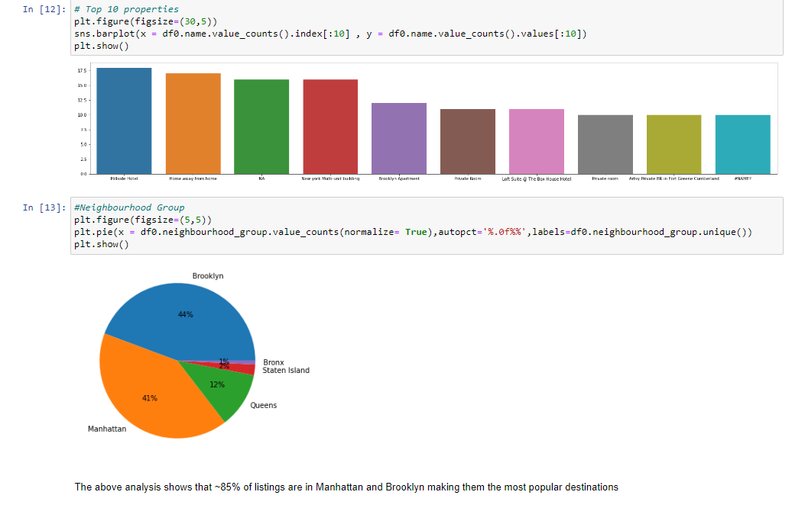

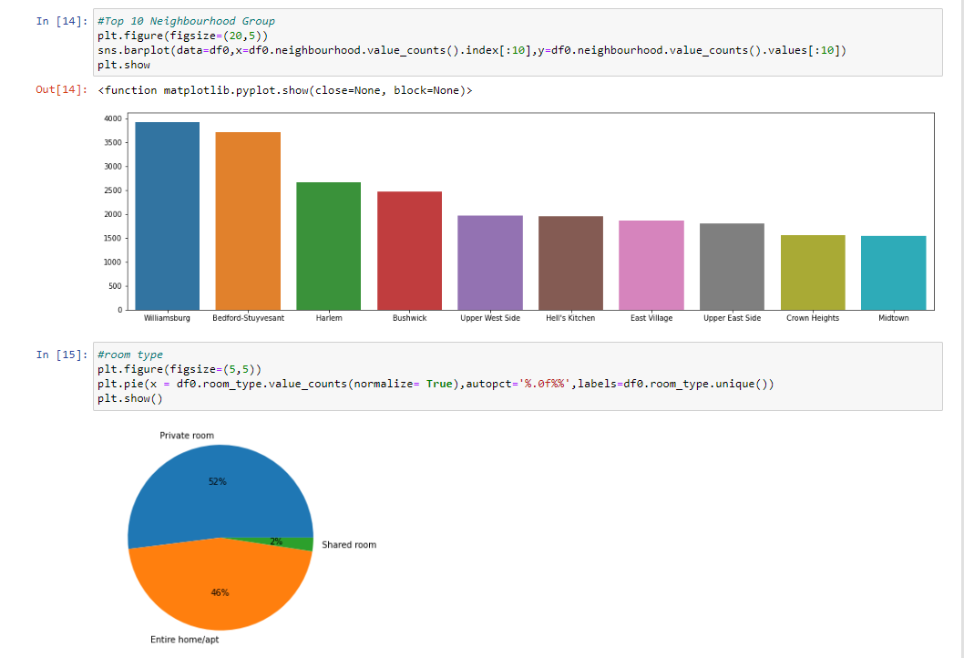

* 1. Performed analysis on numerical variables to understand presence of outliers in data and the distribution of data
  2. 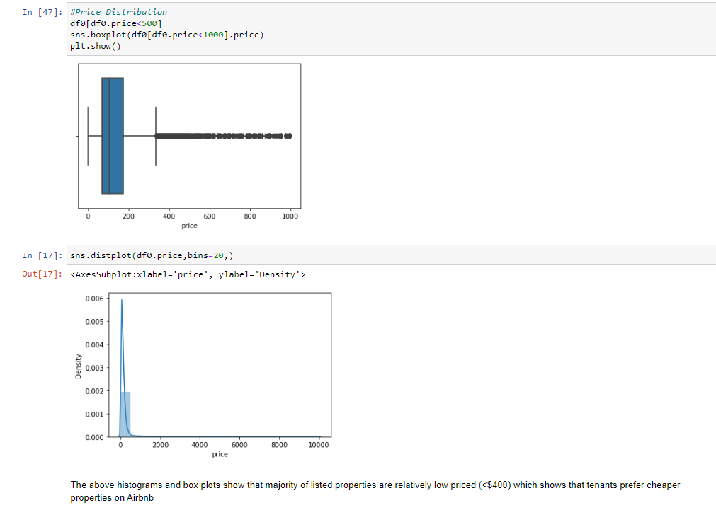

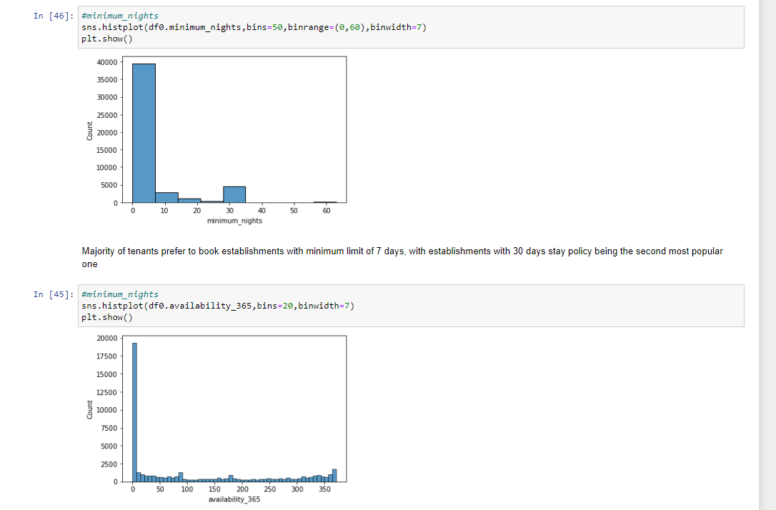

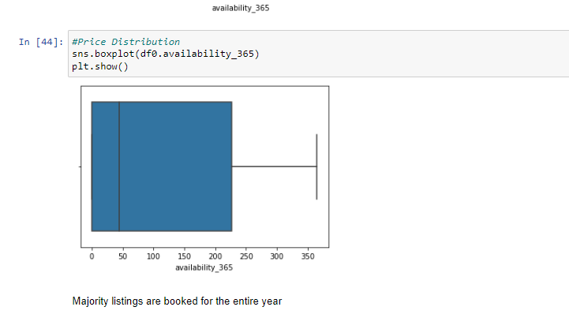

* **Bivariate and Multivariate Analysis**
  1. Performed analysis to understand how different variables are related to each other : Price vs Neighbourhood, availability vs neighbourhood, price vs room types etc. to understand the relationship between different variables and derive insights like:
     1. Price variation by area
     2. Availability based on area to understand the popularity

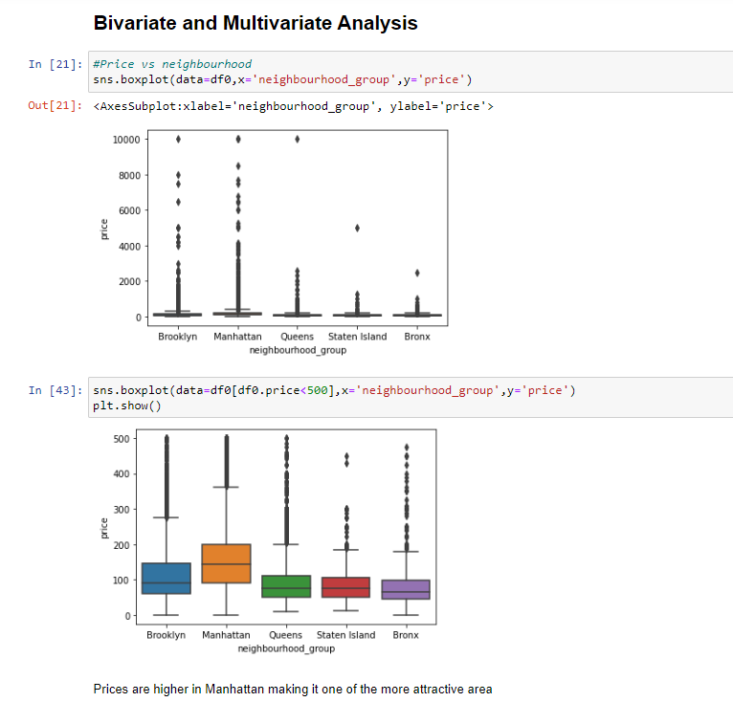

* 1. 